USER MANUAL

Contents

How can you register? 2

How can you Log In? 3

Home page and Toolbar 4

Creating a New Topic 5

Adding Quiz 6

Displaying a Topic 6

Comment on a Topic 7

Solve Quiz 7

Follow a Topic 8

Unfollow a Topic 8

Displaying and Editing Profile Page 9

Add a Review to a Creator 10

Semantic Searching 10

Rate a Topic 10

Vote a Comment 11

Displaying a Topic Pack 11

Topic Recommendations 12

# How can you register?

1. Make sure you are logged out and at the start page of the site.
2. Click to the SIGN UP button at the right top of the toolbar.

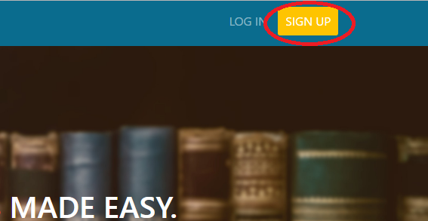

1. A form should be showed in the middle of the page. 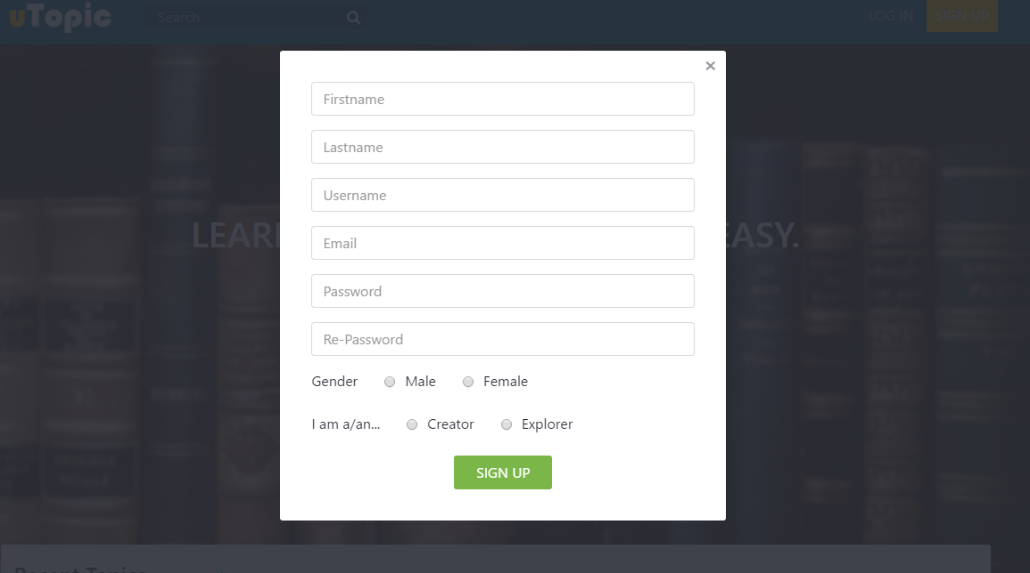
2. Write your First Name and Last Name [Example: Yunus, Seker]
3. Write your username [Example: myunusseker]
4. Write your email [Example: m.yunusseker@hotmail.com]
5. Write your password. It should be between 6 and 20 characters. Re-Write your password.
6. Choose your gender.
7. Choose your role. If you are a creator, you can additionally have a permission to create new topics to teach your experience to others.
8. Press Sign Up button, you will be directed to the index page again. Now you can Log In.

# How can you Log In?

1. Make sure you are logged out, registered and at the start page of the site.
2. Click to the LOG IN button at the right top of the toolbar.



1. A form should be showed at the middle of the screen.

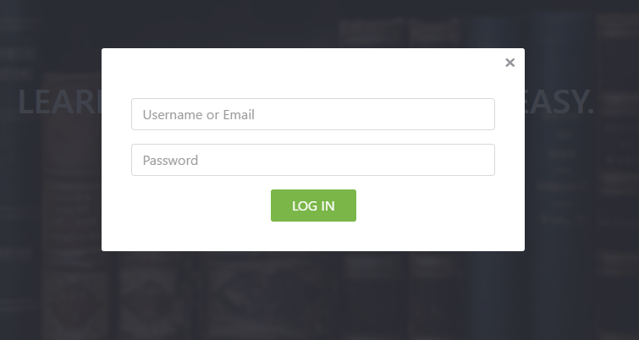

1. Write your username or mail [Ex: myunusseker, [m.yunusseker@hotmail.com](mailto:m.yunusseker@hotmail.com)]
2. Write your password.
3. If you are succeed to log in , you will be directed to your home page.
4. If you are fail to log in, you will be directed to the index page again.

# Home page and Toolbar

1. If you are logged in, you will be directed to this page.

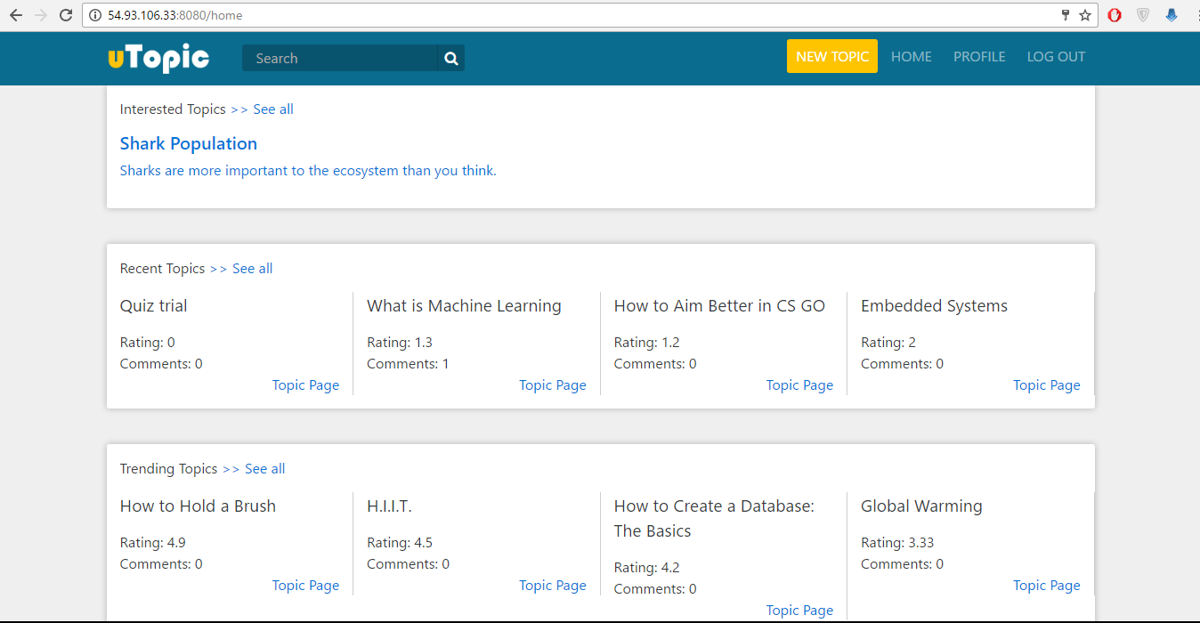

1. In this page you can see a preview of :
   1. Your interested Topics
   2. Recent Topics created in Site
   3. Trending Topics in the Site
2. To see the more topics of those categories, click the “>>See All” button right next to the headers.



1. To go your Profile, click the PROFILE button at the right top of the toolbar.
2. To Log Out, click to the LOG OUT button at the right top of the toolbar.
3. If you are a creator, there will be an additional NEW TOPIC button at the toolbar.

C:\Users\myunu\AppData\Local\Microsoft\Windows\INetCacheContent.Word\toolbar.png

# Creating a New Topic

1. Make sure you are a Creator.
2. Make sure you are logged in.
3. There should be a NEW TOPIC button at the toolbar. Click that button to go to the topic creation.

C:\Users\myunu\AppData\Local\Microsoft\Windows\INetCacheContent.Word\new topic toolbar.png

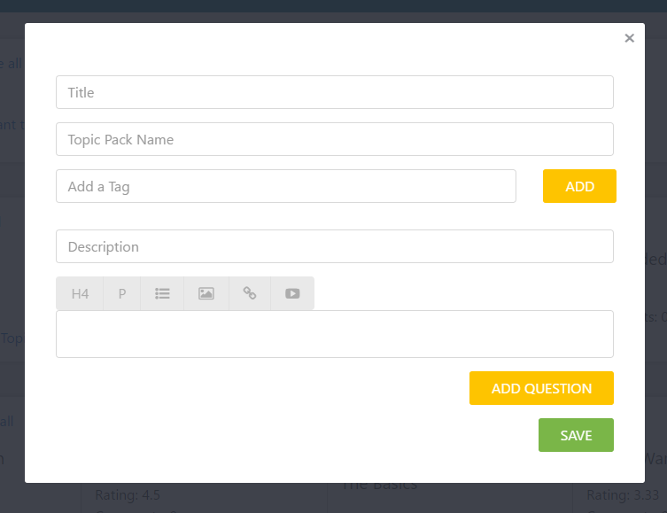

1. Write your topic title [Ex: Java For loops]
2. Write your topic pack name. If you have a topic pack and you want to add your new topic to your topic pack, just start typing your topic pack name. A drop down list will be shown under the input line to give you the topic pack names. If you want to create a new topic pack, just write its name.[Ex: JAVA]
3. Write your tags. The semantic tags are shown when you are typing. Select them and click to the ADD TAG button. Your tag will be shown under the input line.[Ex: Java(an object oriented programming language)]
4. Write your Description and Content. Your description should be shorter than 255 characters.
5. To add questions, read the Adding Quiz part in the User Manual. Then, turn back here.
6. Click to the SAVE button, if you are succeed, you will be directed to your new topic page.

# Adding Quiz

1. Make sure you did the Creating Topic part at the Manual.
2. To add a question, click to the ADD QUESTION button on the topic creation page.
3. For adding options, click to the ADD OPTION button as many times as you want. (Maximum 4 options)

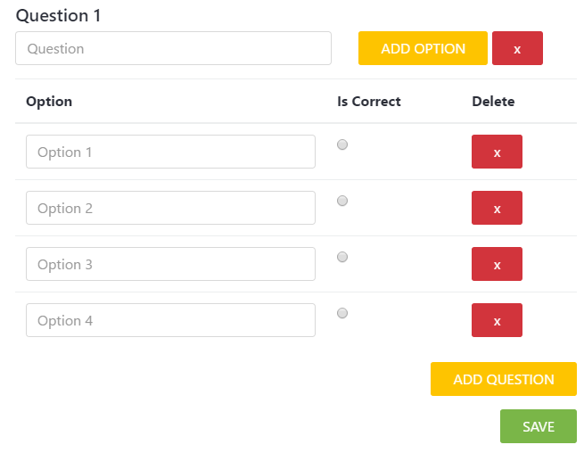

1. Write the question.
2. Write the options.
3. If you want to delete a question, just click the red button right next to the question.
4. If you want to delete an option, just click the red button right next to the question.
5. Make sure you chose the correct option for each question. At least one of the radio buttons under the Column Is Correct should be selected.
6. If you want to add multiple questions, click ADD QUESTION button again and turn to the step 3.

# Displaying a Topic

1. Make sure you are logged in.
2. When you are in the homepage, you will see some topics.
3. Click to a topic’s name.

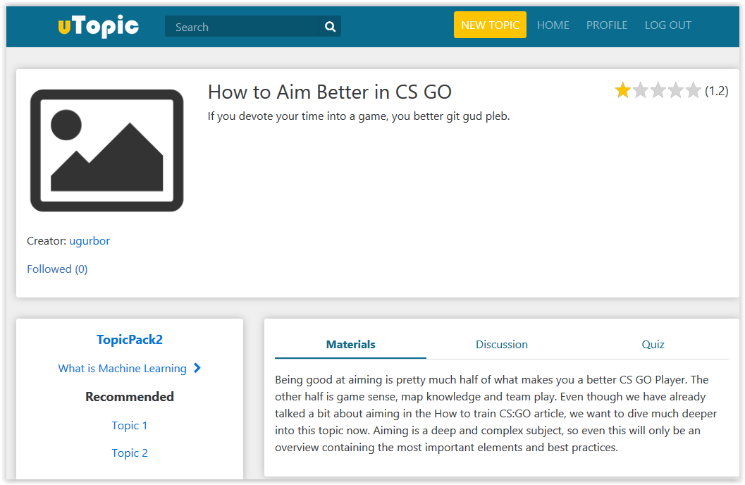

1. You will see the topic’s page on your screen.

# Comment on a Topic

1. Make sure you are logged in.
2. Go to a topic’s page.
3. You will see three sections in bottom of the page.
4. Click to the middle one called “Discussion”.

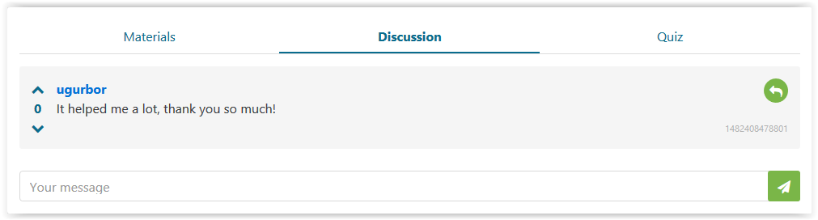

1. Write your comment to the text box.
2. Press Enter or click to the paper-plane button.

# Solve Quiz

1. Make sure you are logged in.
2. Go to a topic’s page.
3. You will see three sections in bottom of the page.
4. Click to the last one called “Quiz”.
5. You will see questions and their choices.

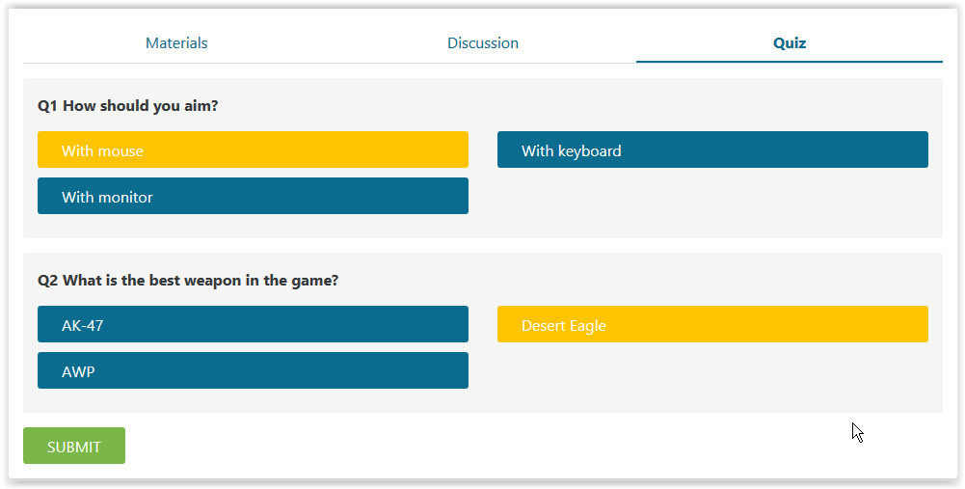

1. Click to the choices which you think that they are true.
2. Click to the “Submit” button.
3. You will see the result of the quiz.

# Follow a Topic

1. Make sure you are logged in.
2. Go to a topic’s page.
3. Make sure that you are not the owner of that topic.
4. You will see a “Follow” button in the leftmost part.

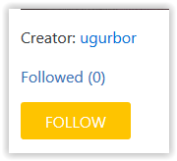

1. After you click that button, you will see that your username is added to the followers and following count is incremented by 1.
2. When you go to homepage, you will see the topic is also appeared on “Interested Topics” section.

# Unfollow a Topic

1. Make sure you are logged in.
2. Go to the homepage.
3. Select the topic which you want to unfollow on “Interested Topics” section.
4. If you do not see the topic which you want to unfollow, you can press to the “See All” button near “Interested Topics”.

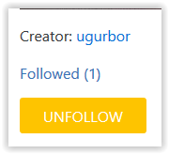

1. After you redirected to the topic’s page, you will see “Unfollow” button in the leftmost part.
2. After you clicked it, you will see that your name is removed from followers list and following count is decremented by 1.
3. When you go to homepage, the topic will be removed from “Interested Topics”.

# Displaying and Editing Profile Page

1. Make sure you are logged in.
2. Click to the “Profile” button, on the top of page.
3. You will see your profile information in a page.

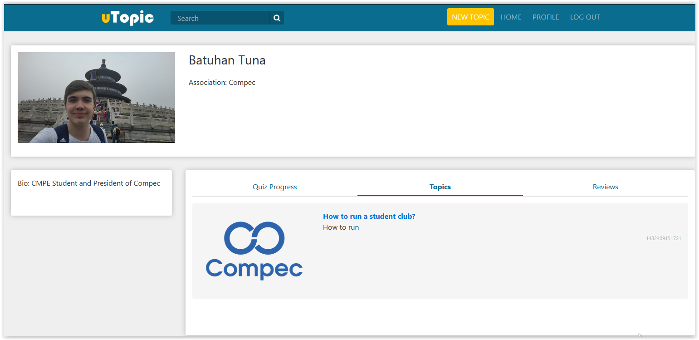

1. You can change your profile picture by clicking on your profile picture. You need to select a photo from your computer.
2. You can change your association by clicking to the association part. A text box will appear and after you write your association, you can save it by clicking the save button.
3. You can change you biography by clicking at the bottom-left section. A text box will appear and after you write your biography, you can save it by clicking the save button.
4. You can see your quiz progresses by clicking to the “Quiz Progress” section.
5. If you are a creator, you can see topics of you by clicking to the “Topics” section.
6. If you are a creator, you can see reviews added by other users by clicking to the “Reviews” section.

# Add a Review to a Creator

1. Make sure you are logged in.
2. Go to a topic’s page.
3. You will see the topic creator’s name, under the picture of the topic.
4. Click to the creator’s name and you will be redirected to the creator’s profile page.
5. Click to the “Reviews” section and you will see a text-box.

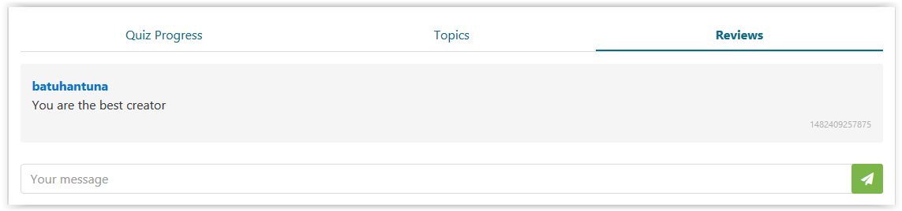

1. Write your review to the text-box and click to the paper-plane button. Pressing to the Enter button is another option.
2. You will see that your review is added to the review list.

# Semantic Searching

1. You will see a search bar on top of the page.
2. Write the term that you want to search into the search bar.
3. Press Enter or click to the search button.



1. You will see the topics related to search terms.
2. If you want to see a topic’s page, you should be logged in.

# Rate a Topic

1. Make sure you are logged in.
2. Go to a topic’s page.

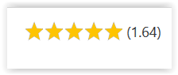

1. You will see five stars on the top-right part of the page.
2. You can click to the stars to give a rate. For example, if you want to give three out of five, you should click to the third star.
3. You will see the topic’s rate is updated.

# Vote a Comment

1. Make sure you are logged in.
2. Go to a topic’s page.
3. Click to the “Discussion” section.

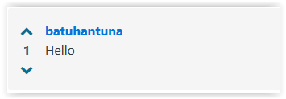

1. You will see the comments which are commited by other users.
2. You will see two arrows on the leftmost part in each comment.
3. If you want to upvote a comment, you can click to the “Up Arrow”.
4. If you want to downvote a comment, you can click to the “Down Arrow”.
5. After voting, you will see the update comment rate.

# Displaying a Topic Pack

1. Make sure that you are logged in.
2. Go to a topic’s page.
3. In the topic’s page, you will see a topic pack’s name.
4. Click that topic pack.

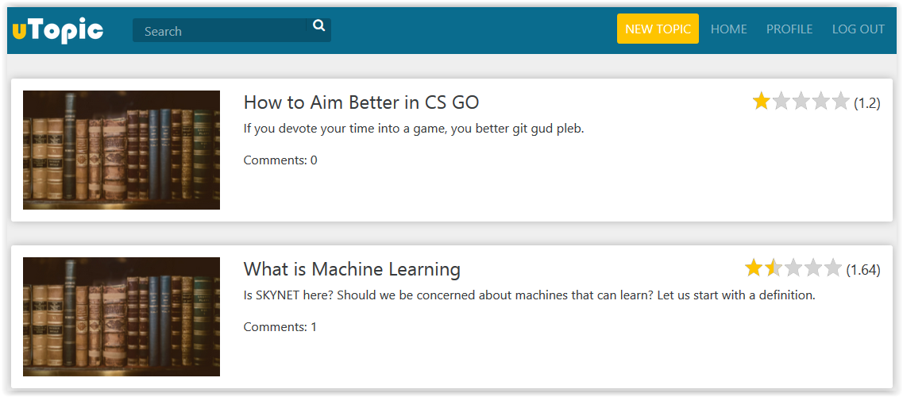

1. You will see all topics which are part of that topic pack.
2. You can also go through all topics by clicking left and right buttons below the topic pack’s name in the topic’s page.

# Topic Recommendations

1. Make sure you are logged in.
2. Go to a topic’s page.
3. You will see some recommended topics in the bottom-leftmost part.

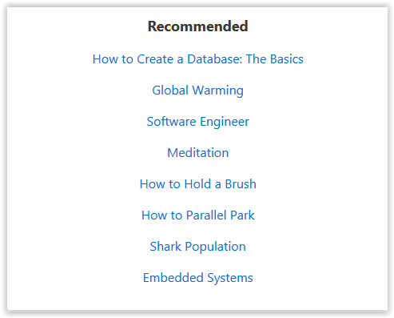

1. These recommendations are based on that topic’s tags and content, so if this topic interests you, these topics may also interest you.